- Block storage breaks data into fixed-size pieces called blocks and stores them. It gives very fast access and high performance, great for databases and virtual machines. Amazon Web Services, Inc.
Object storage stores data as objects with lots of metadata. It’s highly scalable and perfect for large amounts of unstructured data (like images, backups, logs). Amazon Web Services, Inc.
File storage organizes data in folders and files, just like a normal file system you see on your computer. It’s best when many users need to share files easily across a network.
- S3 is an object storage service by AWS that provides high scalability, availability, security, and performance. It allows organizations to store and manage any amount of data for many use cases, such as data lakes and cloud applications, while keeping costs low and controlling access easily. https://aws.amazon.com/s3/

- A bucket is a container in Amazon S3 where data is stored.
It holds objects (files) such as images, videos, documents, or backups, and it is used to organize and manage data in S3.
- S3 does not have real folders. It uses object keys with prefixes that look like folders, but the folder structure is virtual.
- Yes, there are size limitations, but they are very different from a classic filesystem.
In Amazon S3, each object can be up to 5 TB, which is much larger than most files in a traditional filesystem. S3 buckets themselves can store an almost unlimited amount of data.
In a classic filesystem, file size and total storage are limited by the disk size and the filesystem type (for example NTFS, EXT4). These limits are usually much smaller and depend on the hardware.

- Amazon S3 – the original and official implementation by AWS
- MinIO – open-source, S3-compatible object storage
- Ceph (RADOS Gateway) – distributed storage with S3 API support
- Google Cloud Storage (S3-compatible tools) – similar concept, often accessed via compatibility layers
- Wasabi – cloud object storage compatible with the S3 API
- docker run -d -p 9000:9000 -p 9001:9001 --name minio -e MINIO_ROOT_USER=admin -e MINIO_ROOT_PASSWORD=admin123 minio/minio server /data --console-address ":9001"
הרצה ב יוצר לי את השרתPOWESHELL
minio/minio

Image מ-Docker Hub – מכיל את השרת MinIO עצמו
שמירת הנתונים ב C:\minio-data
docker run -d -p 9000:9000 -p 9001:9001 --name myminio -v C:\minio-data:/data -e MINIO_ROOT_USER=admin -e MINIO_ROOT_PASSWORD=admin123 minio/minio server /data --console-address ":9001"

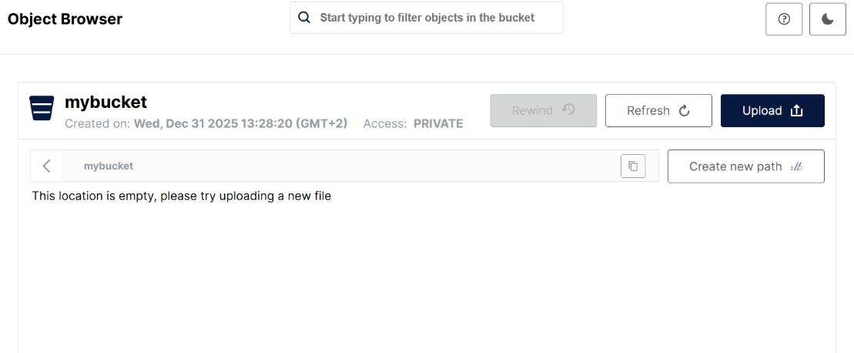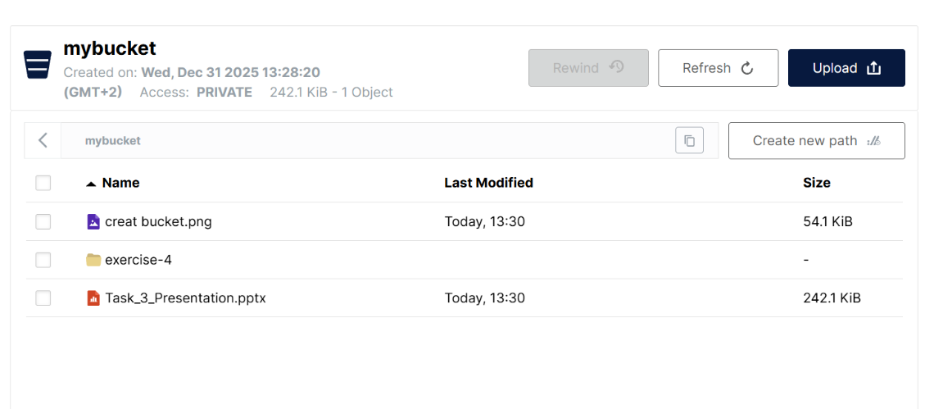
- ClientMinIO.PY
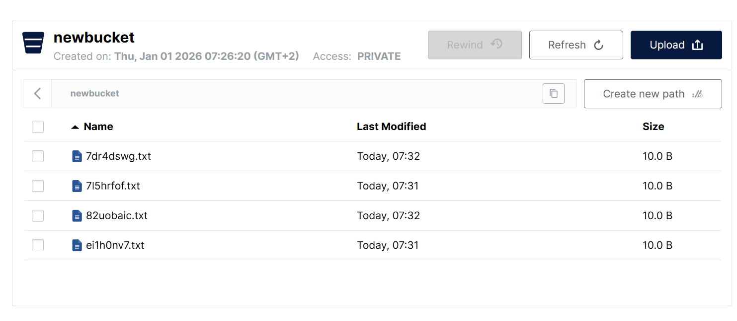
Versioning allows keeping multiple versions of the same object. When an object is updated, MinIO stores the new version without deleting the old one, enabling rollback to previous versions.

